Instructions for using EPA’s Climate and Economic Justice Screening Tool (CEJST)

Your community's eligibility for Community Equi-Tree Grant funding requires a designation of a disadvantaged community in EPA’s CEJST. Areas marked as disadvantaged (blue shaded areas) will be eligible for grant funding. Some municipalities may have some disadvantaged areas that are eligible for funding and other areas that are not eligible within the same community. Be sure the portion of your community where you wish to use grant funds is disadvantaged. The tool works like google maps, simply search for your community in the mapbox address bar, and the tool will show if the area searched is disadvantaged and why it was determined as such.

- Navigate to https://screeningtool.geoplatform.gov/en/#3/33.47/-97.5 and use the address bar to search your community.
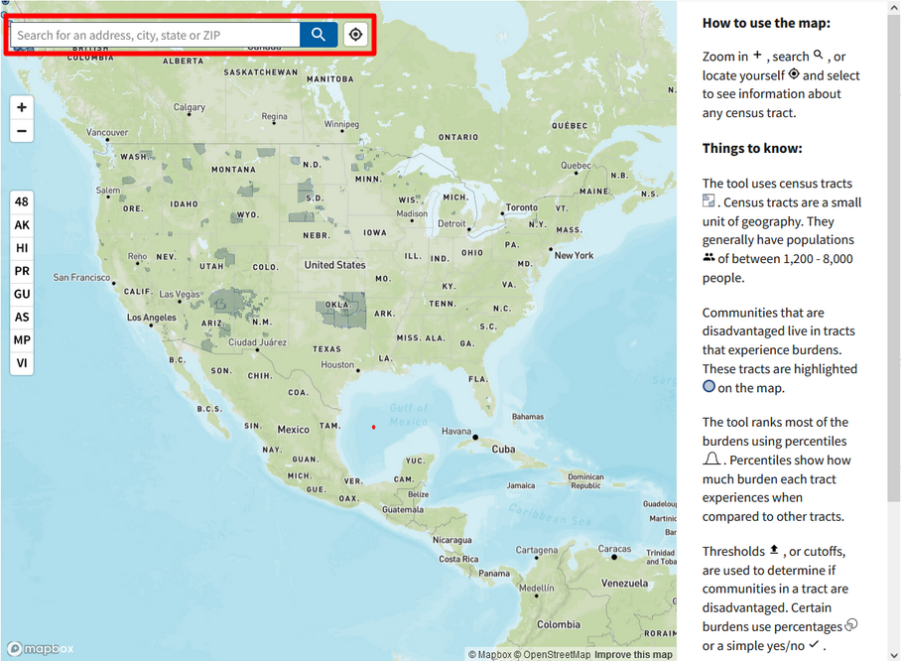

- When you search for your community the map will automatically navigate to the community and show areas that are marked as disadvantaged (shaded blue) and areas not shaded are ineligible for Equi-Tree grant funding. We’ve used Morgantown in our example below. Two areas of the greater Morgantown area are considered disadvantaged because they meet more than one of the burden thresholds and at least one socioeconomic threshold.
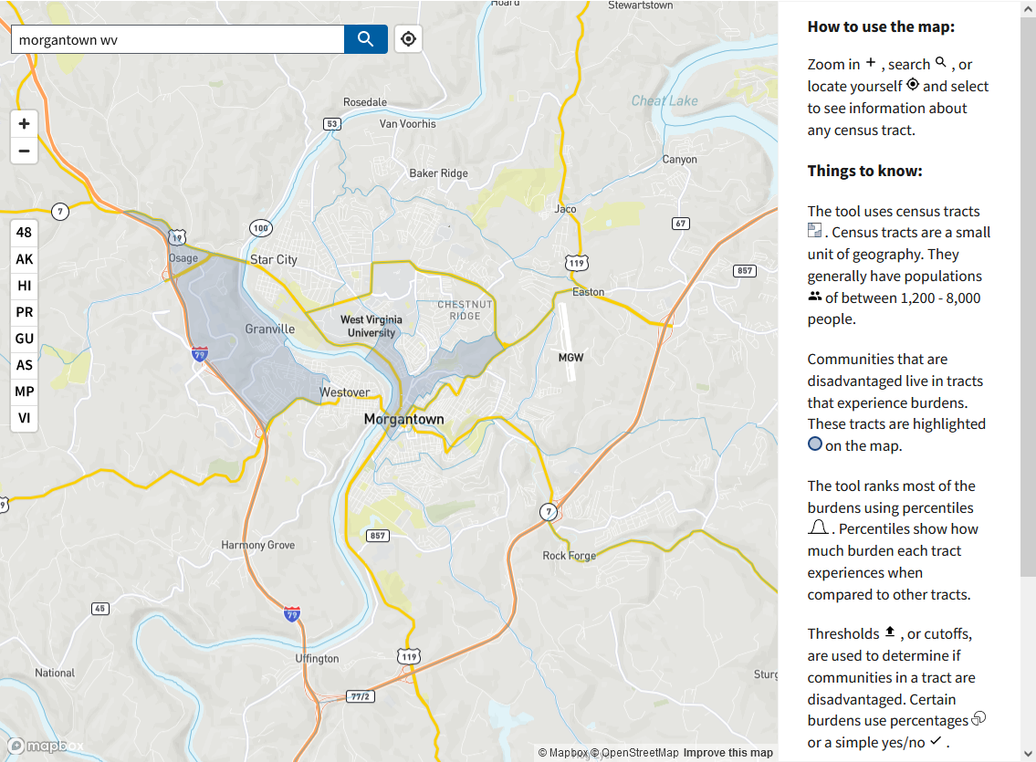

- Click on a shaded area to show why an area is considered disadvantaged. Once clicked, the map will show information about the area and disadvantaged categories. Categories marked with a blue dot indicate that the shaded area is disadvantaged in that category.

- Include the 11 digit tract number where your project is taking place in your application. It is located below the tract information section when you click on a blue shaded area.

See example below.
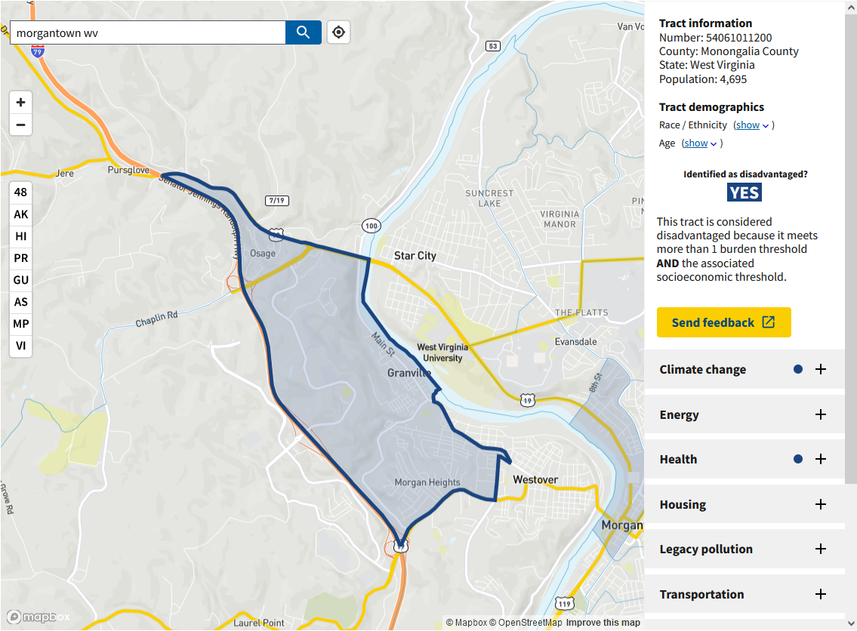

- This parcel has been identified as disadvantaged in climate change, health, and workforce development categories. Click the plus sign to expand a category. When the health category is expanded it shows this area has a high rate of Asthma, Diabetes, Heart disease, and has a high percentile of low income residents.
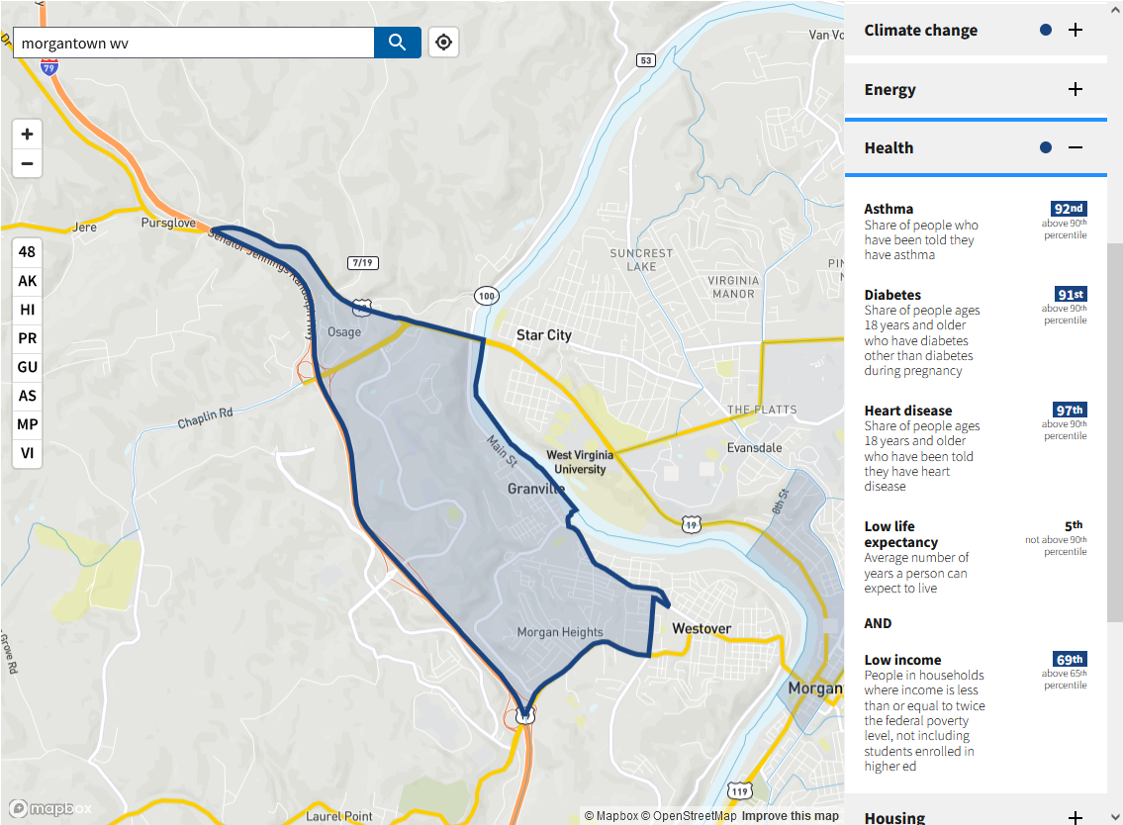

Use these CEJST metrics to build your Community Equi-Tree application and identify areas within your community that are in need of enhanced tree canopies.

