2024
West Virginia
Choose & Cut Christmas Trees

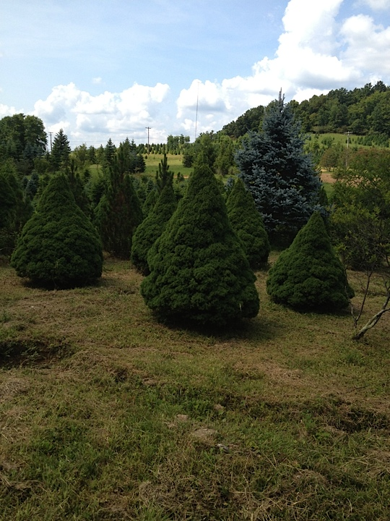

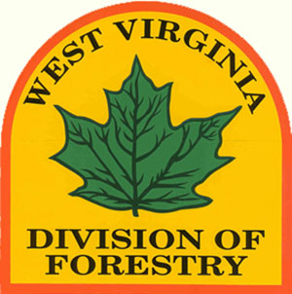
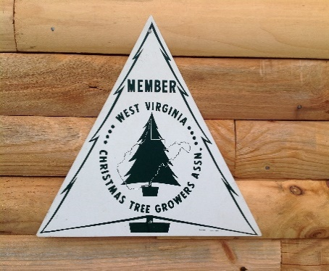

2024 “CHOOSE-AND-CUT” CHRISTMAS TREE FARMS

Selecting a West Virginia-Grown Christmas Tree is the Environmentally Sound Choice

• Do you want the perfect Christmas tree for the holidays?
• Do you want to make sound decisions when it comes to the environment?

Then travel to one of the many choose-and-cut Christmas tree farms, where holiday traditions and environmental stewardship go hand in hand. Our tree farms grow a wide selection and variety of high-quality trees that bring the beauty and aroma of the forest to your home.

While growing on these farms, Christmas trees stabilize the soil, protect water quality, and provide cover for wildlife. Growing Christmas trees absorb carbon dioxide while emitting fresh oxygen. They also beautify the landscape with their classic shape and lush foliage – something not found on artificial trees. Best of all, they can be easily recycled after the holiday.

Gather up your family and friends and get out there! Your perfect Christmas tree awaits at one of West Virginia’s choose-and-cut Christmas tree farms.

Keeping Your Christmas Tree Fresh Through the Holiday Season

Nothing beats the smell of a fresh Christmas tree, but fresh trees need special attention. To keep your tree fresh and beautiful when you get home, as well as to lessen the risk that your tree will become a fire hazard, follow these simple tips:

1. Cut at least one inch off the main stem, place the tree in a clean pail of warm water and put it in a cool, shaded area where it is protected from the wind and the sun.

2. When ready to bring the tree into your home, make another cut of at least one inch off the main stem and place the tree into a water-filled stand as quickly as possible. A bucket of sand and water may also be used in place of a stand. It is always important to maintain a suitable water level .

3. Trim the tree in all its finery, sit back and enjoy your creation throughout the holiday season.

4. Dispose of your tree properly as soon as the holiday season is over. Never attempt to burn a live Christmas tree in a fireplace or wood stove. This can be very dangerous.

Fresh pines and firs will hold their needles for several weeks when treated in this fashion. Spruces will hold their needles for at least two weeks.

To be assured that you get the tree you want, please call the farm before making the trip.

Table of Contents

Calhoun County
Westfalls Christmas Tree Farm

Fayette County
Crickmer Farms

Hardy County
Riggleman’s Christmas Trees

Lincoln County
Wilkerson Christmas Tree Farm

Mercer County
Bluestone Tree Farm

Monongalia County
Mulkeen Landscaping Tree Farm

Nicholas County
Yagel Poor Farm
Gray’s Park Place Trees

Pendleton County
Brushy Mountain Tree Farm

Preston County
King’s Trees

Tucker County
Seven Island Farm LLC

Upshur County
French Creek Christmas Trees

Webster County
Lake’s Tree Farm

Wetzel County
Jolliffe Nursery

Wood County
Evergreen Christmas Tree Farms
Country Roads Christmas Tree Farm

Christmas Tree Safety

Division of Forestry Mission

The listings in this publication do not imply endorsement by the WV Division of Forestry or the State of West Virginia.

The WV Division of Forestry and the State of West Virginia do not guarantee the services or products listed here.

Due to changes that may occur, the WV Division of Forestry and the State of West Virginia cannot verify the availability of businesses on the list.

Calhoun County

Westfalls Christmas Tree Farm – Chip Westfall
138 Lost Road
Grantsville, WV 26147
304-354-6424 or cell 304-373-4020
Chipw19@icloud.com

Directions: Four miles south of Grantsville on Route 16. Seven miles North of Millstone. GPS will take you to 138 Lost Road. Farm is located 100 yards off Route 16.

Hours open: Open every weekend starting Thanksgiving weekend. Other dates and times available upon request.

Products: Norway Spruce and White Pine in a variety of sizes from 5 foot to 10 foot. They also have wreaths

Services: Saws are available or they will cut for you.

Fayette County

Crickmer Farms - Al and Louise Tolliver
1635 Crickmer Road, Danese, WV 25831
304-484-7661
altolliver@crickmerfarms.com

Directions: From I-64 take Exit 143. Turn north on Highway 20 and go five miles to Meadow Bridge. Turn left on Highway 31 towards Danese. Go four miles to the second left on Alaska Mountain Road (Millbrook Baptist Church sign). Follow single-lane paved road three miles to farm.

Hours open: Thanksgiving Week: Closed Monday-Thursday Open Friday-Saturday-Sunday, 10 AM – 5 PM.

After Thanksgiving: Closed Monday-Tuesday Open: Wednesdays through Sundays while supplies last 10 AM – 5 PM.

Products: Fraser firs, Concolor fir and Serbian Spruce 6-14’, larger trees available, so call ahead for sizes. The Christmas shop will be displaying our many different size Fraser Fir wreaths, swags, boughs & garland. Also, centerpieces, unique Christmas Tree ornaments and holiday decorations. Complimentary hot chocolate and candy canes will be available at the Christmas Shop.

Christmas Shoppe and precut tree displays will remain open until 5 PM.

Services: Bow saws, drag sleds, tying string are provided as needed. Baling of trees and other assistance will be provided to assure an enjoyable visit to our farm.

Hardy County

Riggleman’s Christmas Trees - Michael and Kelly Riggleman
132 Duffy Hill, Moorefield, WV 26836
304-538-2856

Directions: Take Winchester Avenue to Route 7 or South Fork Road in Moorefield. Take first left at Paskell Hill, continue straight, and turn onto Duffy Hill Road. The road ends at the farm.

Hours: Beginning Thanksgiving weekend, open Tuesday – Friday 1 PM to Dark, Saturday 10 AM to Dark, Sunday - Noon to Dark.

Products: Scotch pine, Norway and Blue spruce, Douglas and Concolor fir.

Services: Baling, drill for stand.

Lincoln County

Wilkerson Christmas Tree Farm
12 Christmas Tree Lane (P.O. Box 6), Griffithsville, WV 25521
304-524-7008 or 304-524-7459
wilktreefarm@aol.com

Directions: Located 1/4 mile off WV State Route 3 on Sam’s Branch Road in Griffithsville. Take left on Christmas Tree Lane at bridge. Follow signs to parking lot.

Hours: Open 7 days/week from 10:00 AM to 5:00 PM while supplies last starting Saturday, November 30th. Please call to make sure farm is open after first week.

Products: White Pine, Norway Spruce, and a limited number of other species. Also available for sale: wreaths, door swags, centerpieces, tree bags, stands, greenery and ornaments.

Services: Saws, tree shaker, free baling, free Forest Fresh needle retention product, rope for securing to vehicle, assistance with loading tree on your vehicle, restroom, warming fire (weekends), picnic tables and benches in fields. Easy access and parking.

Mercer County

Bluestone Tree Farm - Dave Stevens
3517 Stovall Ridge Road, Camp Creek, WV 25820
304-960-5485

Directions: From I-77 take Exit 20 (Camp Creek) turn right (south) on U.S. 19; go two miles to Stovall Ridge Road; turn right and go 3.2 miles to the farm.

Hours: Opening Thanksgiving to December 15, 9 AM – 5 PM, seven days a week.

Products: Canaan Firs, Norway Spruce and small number of pines, other firs and spruces. Wreaths, Forest Fresh, tree stands, snacks and drinks.

Services: Hand saws, cord for tying on vehicles, tree baler available.

Other: We will comply with recommended COVID-19 requirements.

Monongalia County

Mulkeen Landscaping Tree Farm - Francis X. Mulkeen
743 Sleepy Hollow Road, Independence, WV 26374
304-292-0059
www.mulkeenlandscaping.com

Directions: Follow signs - Take Route 119 south out of Morgantown, WV (Grafton Road). Go seven miles past the intersection with I-68. Turn LEFT on Gladesville Road. Go two miles and turn RIGHT on Arden Peters Road. Go one mile and look for signs.

Hours: Opening the Friday after Thanksgiving to Christmas Eve, Fridays, Saturdays and Sundays only, Daylight – Dusk. Allow time for tree selection in evenings as no after-dark hours in field.
Products: White Pine, Canaan Fir, Blue and Norway spruce. All trees one price any size. Thousand of trees to choose from. Also available are wood craft items, stained glass, mosaic art works, bird houses and feeders for sale. Balled and burlapped trees

Services: Saws provided and twine for tying tree. Good access roads.

Nicholas County

Yagel Poor Farm - Art Yagel
726 Eureka Road, Craigsville, WV 26205
(Mailing address PO Box 638, Summersville, WV 26651)
304-575-2787
artysmoke@hotmail.com or www.facebook.com/YagelPoorFarm

Directions: From the Craigsville traffic light / intersection of WV Routes 20/55. Take WV Routes 20/55 south toward Richwood 2.0 miles; turn off sharp right on Crupperneck Road Rt 14; Follow paved road 1.6 miles to old church at top of hill; turn left on Eureka Road and go ¾ mile to red farm gate on the right.

Hours: Open – Friday, Saturday, Sunday 9:30am to 5:00pm starting Friday November 29, 2024. Closed Monday, Tuesday, Wednesday and Thursday. Last day – Sunday, December 15, 2024.

Products: White and Scotch Pine; Norway Spruce and limited Blue Spruce. Also have greens; pinecones; tree stands and watering elves.

Services: Candy canes for our guests; hand saws provided; free tree shaking and mesh baling; cutting and loading assistance, twine provided, chemical restroom.

Sorry but we cannot accept or process debit or credit cards, or other electronic payment methods. We accept cash and checks drawn on local banks.

The farm will follow recommended health and safety protocols. Please do not visit the farm if you have Covid (or other infectious disease) symptoms or active infections. The farm will sanitize hand saws after each use. Sanitizer and masks will be available.

Please refer to our Facebook page for updated information closer to tree season.

Gray’s Park Place Trees - Brent & Julie Gray / Shawn & Sheila Gray / Colton, Brianna and Gracelyn Gray / Clay and Rachel Gray
362 Honeysuckle Lane
Mt. Lookout, WV 26678
304-640-4133 or 304-619-7555
Brentgray65@yahoo.com

Directions: From U.S. Route 19 turns onto West Mount Lookout Road. Stay left when road splits then turn right onto Honeysuckle Lane and stay straight until you reach the tree farm.

Hours: Open Friday, Saturday and Sunday after Thanksgiving then Saturday and Sunday from 9 AM to 4 PM through mid-December while supplies last weekends only. Come and reserve a tree at any time.

Products: White Pine, Canaan Fir and Norway Spruce.

Services: Hand saws & knee pads provided. Free tree shaking & mesh baling. Cutting and loading assistance. Twine provided. Tree stands for sale. Ball & Burlap available upon request for an additional charge.

Find us on Facebook: Gray’s Park Place Trees

Pendleton County

Brushy Mountain Tree Farm -Travis and Teresa Heavner
623 Skiles Pitsenbarger Road
Franklin, WV 26807
304-358-2511
theavner40@hotmail.com
Find us on Facebook at Brushy Mountain Tree Farm LLC

Directions: 33 East from Franklin to Long Mountain General Store, turn left on Troublesome Valley Road. Go 5 miles and watch for signs.

Hours: Opening day after Thanksgiving, 10 AM – 6 PM. Thereafter, Friday 3 – 6 PM, Saturday 10 AM – 6 PM, and Sunday 11 AM – 6 PM.

Products: Frasier, Douglas, Canaan & Concolor Fir 5-12 feet. Also available are wreaths, centerpieces, tree stands, and other tree supplies.

Services: Shaking, baling and field assistance.

Preston County

King’s Trees - John and Bill King
5372 Old Route 73, Bruceton Mills, WV 26525
304-290-1329

Directions: From Morgantown, take I-68 east to Exit 15 Coopers Rock. Go left on Old Route 73 then turn right. Farm is five miles on right. From Maryland, take I-68 to Bruceton Mills Exit. Turn right to make left at Antique Mall. Go three miles to farm on left.

Hours: Opening Thanksgiving through December 24th. Open Monday through Friday Noon - 4:30 PM, Saturday 8 AM - Dark, and Sunday 11 AM – Dark or by appointment.

Products: Frasier, Canaan and Concolor Fir, Blue and Norway Spruce, and White, Scotch and Red Pine. Also, for sale are wreaths: canes & crosses both plain and decorated.

Services: Saws and tree netting.

Tucker County

Seven Islands Farm, LLC – Tom and Georgette Plaugher
223 Riverbend Estates Rd
Parsons, WV 26287
304-621-3515

Directions: At the stoplight in Parsons, take Route 72 North. Turn right onto Holly Meadows Road. Take the first right onto Moss Lane. Take the second left onto Riverbend Estates Road. Turn into the second driveway on the left.

Hours: Open Saturday and Sundays, Noon to 5:00 PM.
First Saturday after Thanksgiving until the first Sunday before Christmas Eve or until sold out.

Products: Balsam Fir, Canaan Fir and Frazier Fir Christmas Trees, Wreaths and Garland.

Services: Saws provided, baling and assistance with the trees.

“Christmas in the Meadows” Craft show and sale held annually on the first Saturday in December.

Upshur County

French Creek Christmas Trees - Ronald and Tillie Fowler
943 Beechtown Road, French Creek, WV 26218
304-924-5584 or 304-516-4919 or 681-837-7045
wvchristmastrees@gmail.com

Check us on Facebook – French Creek Christmas Trees - for special events and updates.

Directions: Ten miles south of Buckhannon, WV, on Route 20, turn right at the “French Creek Christmas Trees” sign. Immediately turn left onto Beechtown Road. We are 1-mile down Beechtown Road on the left.

Hours: Opening day after Thanksgiving. Open: Friday, Saturday and Sunday 10 AM – 5 PM. Call for an appointment on closed days. No early tree tagging this year. We DO NOT accept credit cards.

Products: White Pine, and Canaan Fir.

Services: Bow saws provided, wagon rides to and from field if desired, assistance with tree from field to loading, tree baling. Free coloring books and candy canes for the children. Pets are welcome if leashed.

Webster County

Lake’s Tree Farm - Mayford D. Lake
109 Alpine Drive, Hacker Valley, WV 26222
304-493-6473
Lakejanice0@gmail.com

Directions: Take County Route 16, Lick Run Road, off State Route 20 near top of Hodam Mountain. Go 0.3 miles and bear right. Go 0.5 miles to the tree farm sign.

Hours: Open from the day after Thanksgiving through Christmas Eve; Saturday 8 AM - 6 PM, Sunday 1:30 – 5 PM, and by appointment.

Products: Canaan Fir, also, for sale are boughs of Canaan Fir.

Services: Saws, tie down strings and field assistance.

Wetzel County

Jolliffe Nursery
24109 Mountaineer Highway, Knob Fork, WV 26581
304-775-2141

Directions: Approximately 8 miles west of Hundred, WV, on Mountaineer Highway (Route 7). Twenty-one miles east of New Martinsville, WV.

Hours: Opening November 23 & 24 from Noon to 4 PM. November 29, 30 & December 1. Thereafter, Saturday and Sunday Noon to 4 PM, or by appointment. While 2024 supply lasts.

Products: Fir, Spruce and Pine of all sizes.

Services: Giant trees for town and church celebrations. Call for information.

Checks or Cash only. No bathroom facilities.

Wood County

Evergreen Christmas Tree Farm - Terry Dunn
244 Viscose Road
Parkersburg WV 26101
304-489-9209 or 304-483-0293
tldunn1@live.com

Directions:
From Mineral Wells I-77 take Route 14N 1 mile, turn right onto to Pettyville Road, take Viscoe Road 1/8 mile to farm.

Open: 11-28 Thursday – Sunday ONLY! 9:00 AM to Dark.

Choose N Cut only – No Retail Lot!

Products: Scotch, White Pine and Norway Spruce – up to 7 ½ feet.

Services: Saws, tie string and balers available. Free tree drawings and candy canes for kids.

Covid Concerns: If you have a cough, fever, etc. please consider having friends or family members come for your tree or consider wearing a mask.

Thanks and Be Safe!

Country Roads Christmas Tree Farm – Kristen & Ashley Dunn-Kerr
968 Chesterville Road
Mineral Wells, WV 26150
865-809-2190
Adunn1791@yahoo.com

Directions: Route 14, 1 mile past Mineral Wells School, turn right onto Chesterville Road, farm is 1 mile on right.

Hours:Open: 9-5 weekends only(Saturday & Sunday), starting the Saturday after Thanksgiving until supplies last or the Sunday before Christmas.

Products: White Pine, some small Norway Spruce & Leland Cypress.

Services: Saws, tie string & baler available. Assistance available for cutting, shaking, baling & securing to car if needed. Free hot cider/hot chocolate. Free tree drawing, candy canes for kids & Christmas music. Bonfire – weather dependent.

Christmas Tree Safety

• Buy locally grown Christmas trees if possible. Bounce and shake the tree. Pull the needles. If the needles fall, the tree is not fresh.

• Just before the Christmas tree is placed in the tree stand, make a slanting cut an inch or two up the trunk from where the tree was originally cut. Removing this lower inch or two will produce a fresh, clean surface that will allow the tree to absorb water easily.

• Keep the base of the tree under water at all times. A Christmas tree may use a quart of water a day, so keep a close watch on the water supply.

• Certain other precautions should be taken to ensure a safe Christmas. All lights should be inspected for faulty wiring and sockets. If any defect is found, the set should be discarded. Only light sets carrying the Underwriters Laboratory safety seal should be used. Other sets may be dangerous.

• Keep all flammable decorations, such as paper or cotton, away from the Christmas tree. Angel hair, snow spray, and white plastic foam are common decorations on Christmas trees. When used separately, angel hair and snow spray are essentially safe. But the National Fire Protection Association reports that when snow spray is used on angel hair, the combination is so flammable that just a touch of fire will cause it to burst into flame. While plastic foam may appear to be fireproof, it may burn if ignited by a spark.

• Artificial trees may be dangerous, too. Never string lights on a metal tree. A short circuit may easily electrify the tree and cause serious injury to anyone coming in contact with it. Colored spotlights should be used to illuminate this type of Christmas tree.

WV Division of Forestry Our Mission

The West Virginia Division of Forestry is committed to protecting, nurturing, and promoting the wise utilization and thus the sustainability of our state’s forest resources.

Our Programs

Fire Protection: Responsible for protecting nearly 12 million acres of state- and privately-owned forestland across West Virginia from wildfire.

Investigative Unit: Investigates all violations of the state’s fire laws and enforces violations of the Logging Sediment Control Act of 1992.

Water Quality: Issues licenses to anyone who buys timber or logs for resale or who harvests timber within the state and provides training and certification for loggers in accordance with the Logging Sediment Control Act.

Managed Timberland: Promotes sustainable forestry within the state by providing a formula-based method of taxation for forestland.

Forest Management: Provides cooperative forest management programs for private nonindustrial forest landowners to promote sustainable forestry practices. Also, regulates the digging of ginseng, manages seven state forests.

Urban and Community Forestry: Helps municipalities throughout the state establish long-term tree care programs

West Virginia Christmas Tree
Growers Association
Since 1954

Growing and marketing high quality products for your family and the consuming public. The operators of the Association’s member farms are true stewards of the land and grow “Real” trees to help in the conservation and improvement of our natural resources.

Contributions from the WV Christmas Tree Growers Association help make this publication possible.

